Use-Case Realization Report
Start Cylinder Production Process

Issue <1.0>
Revision History
Date | Issue | Description | Author
<29/apr/11> | <1.0> | Initial Document | Koh Ming Jin

Table of Contents
1. Brief Description 4
2. Flow of Events 4
2.1 Standard Flow 4
2.2 Exception 4
3. Interaction Diagrams 4
3.1 Collaboration Diagram for Start Cylinder Production Process 4
4. Participating Objects 4
4.1 Workflow 4
4.2 Work Flow Panel 4
5. Class Diagrams 5
5.1 Domain Class Diagram: Start Cylinder Production Process 5
6. Derived Requirements 5

Use-Case Realization Report
Start Cylinder Production Process

Brief Description
This use case enables an operation manager to start cylinder production process.

Flow of Events
The standard flow of events for this use case and any exceptions are described in the following subsections. See section 3.1 for an overview of the participating Actors and Domain Objects.

Standard Flow
The flow of events is described as follows:

- The use case starts when Operation Manager views a list of cylinder processes.
- The Operation Manager will select which cylinder process to start and click on the start button to initiate the cylinder production process.
- The use case terminates.

Exception
- Unable to start a process. The actor can only start a cylinder production process which is not running or has not been started before. The start button for any existing running process will be disabled.

Interaction Diagrams

Collaboration Diagram for Start Cylinder Production Process
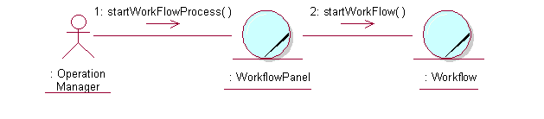

Participating Objects

Workflow
This object stores the details concerning the work flow process information of the cylinders.

Work Flow Panel
This screen is used to display the cylinder information details and allow actors to update the cylinders’ process steps. The Director, Department Manager and Operation Manager actors use this object.

Class Diagrams

Domain Class Diagram: Start Cylinder Production Process
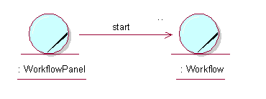

Derived Requirements
The Operation Manager PC keyboard and mouse will be used to enter cylinder production process information details (if any) and view all the system responses.

